Discussion Post

For this discussion, I used Visual Paradigm to draft an OWASP-identified security weakness called SQL Injection. Visual Paradigm enables the correct generation of UML-compliant diagrams like flowcharts, class diagrams, and sequence diagrams that assist in determining the security vulnerabilities during the software development process.

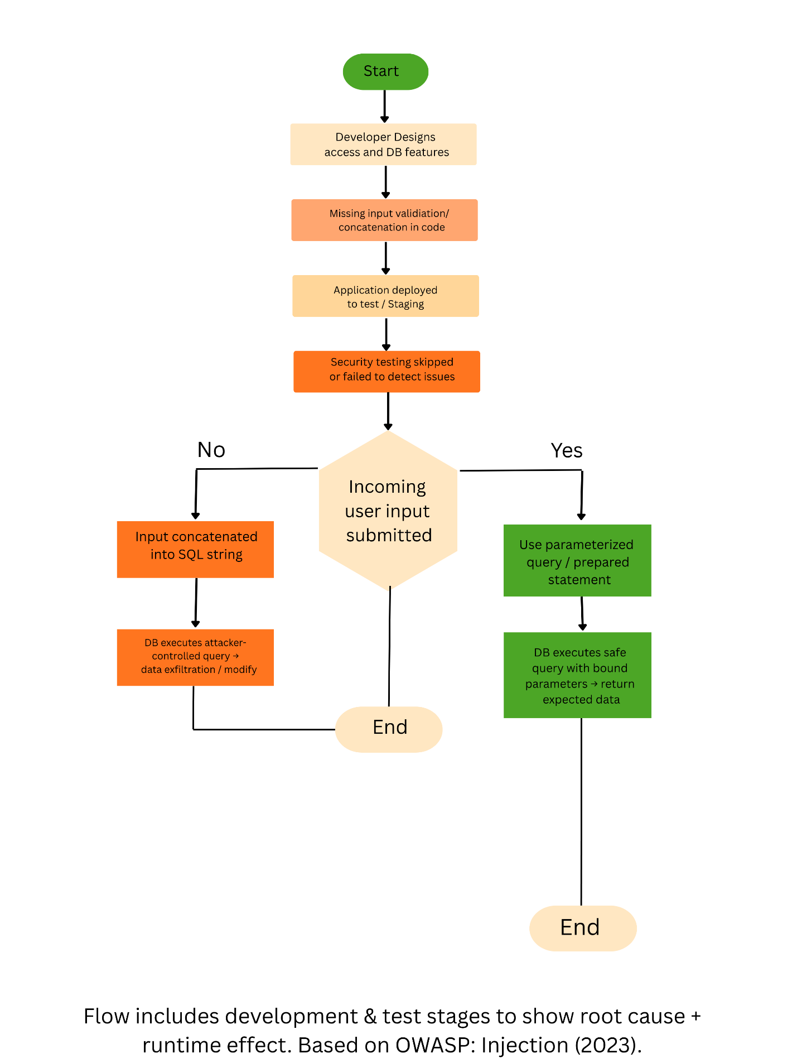

The flow chart that I have drawn shows how the SQL injection can be exploited by the way of not following the insecure practice of coding. This has a starting point of the design and coding stage whereby user input is concatenated to an SQL query string directly and not properly validated. In testing, the vulnerability may end up in production because of lack of proper security checks. An attacker can take advantage of it at run-time by placing malicious SQL code in input fields resulting in the unauthorized access to or manipulation of data. The safe option in the flow diagram illustrates the use of parameterized queries and input verification, which are the ways to be sure that the input by the user is safely processed and the database integrity is kept (OWASP, 2023).

Three UML models come in handy to design secure software and overcome such risks. The Class Diagram assists in determining the interrelations between components of the system (e.g., controllers, data access levels, and databases) within which there are trust boundaries. The Sequence Diagram is an indication of message communication between objects and thus there should be input validation point before database queries. Lastly, the Activity Diagram (or enhanced flowchart) uses the vulnerable and secure process flows and can be used to communicate risks to developers and stakeholders. These models can be used in the initial stages of design to enable developers to detect possible weakness beforehand and eliminate them.

Using these UML techniques via Visual Paradigm, the software teams will be able to incorporate secure design concepts in all the phases of the development life cycle that can efficiently manage the security risks and still be consistent with the secure software engineering practices.

References:
Bennett, S., McRobb, S. and Farmer, R. (2006) Object-Oriented Systems Analysis and Design Using UML https://archive.org/details/objectorientedsy0000benn_i1d1
Booch, G., Rumbaugh, J., & Jacobson, I. (1998). The Unified Modeling Language User Guide (1st ed.). Addison-Wesley https://patologia.com.mx/informatica/uug.pdf
OWASP (2023) OWASP Top 10: Injection. Open Worldwide Application Security Project https://owasp.org/Top10/A03_2021-Injection/

